Rosa Aquino

Ernest Gaddi

Marilyn Henein

Sargis Hovhannisyan

Raul Pool

Prof. Mushkablat

COMP 467 Multimedia Systems

4 December 2017

**1. Project Name**

Online Doodle.

**2. Project Goal**

To provide a simple, intuitive website application for users to cut, crop, and draw over images and have the ability to save and download them.

**3. Project Description / Abstract**

The project is a web based image editing tool like Microsoft Paint. The application will let the user to upload a picture and edit it with different tools such as a paint brush, shape maker, etc. and download the image after editing it. The application will also provide the user with a blank canvas to draw on and download their image once they are done. There will be many different ways to customize their artwork by having the ability to choose from many different colors and thickness of brush.

**4. User Specification**

- Nonfunctional and Functional requirements

- Functional - features, functions, UI/UX of the project

* New File
  + User has the ability to create a blank new image without having to upload a file, clearing the image of previous edits.
* Open File
  + User has the ability to choose a file from their local machine and open it in the browser to edit. This file should be a PNG, JPEG, or PDF.
* Save File
  + User will be able to download an edited image from the browser if they want to save it. The file will not be saved onto a server, so if the user accidentally closes the tab, the work shall be deemed unsavable.
* Change Tool
  + The ability to change the tool the user wants to work with.
    - For example, switching between the paintbrush tool and the pencil tool.
* Tool Properties
  + Change Color
    - The user will have the ability to select different colors as they use the tools, and the color will be applied to every tool until the user picks a new color.
  + Change Size
    - If using the pencil tool, the user will have the ability to change the thickness of the tip. This should help with the ability to fill in or draw in a small, tight area of the picture.
  + Change Style
    - The use can toggle between two modes of shape drawing: stroke, which will outline the shape with the user’s defined size and color, or fill, which fills in the shape with the user’s defined color.
* Eraser Tool
  + Erases marks you make when you draw over using the eraser tool.
* Line Tool
  + Ability to make a straight line at any angle of any length up to the dimension of the canvas.
* Shape Tool
  + Ability to generate circles and squares. As with the lines, can be any size up to the height and width of the canvas. Shapes should maintain their structure as they are resized.
* Resize
  + Ability to change or skew the height or width of a picture.
* Crop
  + Ability to cut a specified portion of the current into a smaller image.

- Non-functional requirements - Executional performance

* The application should be able to run on nearly all updated browsers.
* The application should only have access to the files when selected by the user.
* The application is not allowed to communicate with cloud services or allowed to save the user's pictures remotely.
* The application should respond to mouse movement in real time.

**5. Architecture**

* MVC
  + Model
    - Using Javascript. The current state of the application. This details the current tool, relevant mouse positions( current, start position when using a tool, previous position when painting for smoothing ).
  + View:
    - Using HTML/Javascript/CSS. HTML is used to display the current state of the model to the user, with a conjunction of Javascript and CSS to alter and style the HTML elements when changes are made to the model.
  + Controller
    - Using Javascript. The code that alters the model from user input for the application to function. Using Javascript events, user input is obtained and data is modified as the user desires.

Use Case Diagram 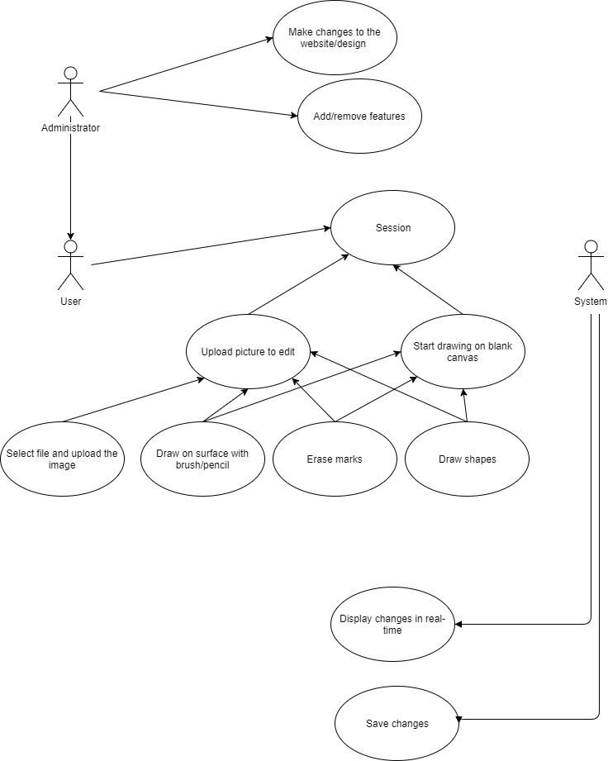

**6. Code Guidelines**

- Naming conventions

-Our code will be organized using the camelCase standard. To ensure that code looks uniform and is easy to read, we will strongly use indentation.

- Paradigms

- Event driven

* Listens for mouse clicks to start and stop the use of a tool
* Tracks mouse movement to draw, erase and crop.

- Functional

* Each tool is an individual function, code is clear and concise.

-Structured

* Application is written to be clean and have nested control structure.

-Imperative

* Paint/Resize tools and GUI functions track the state for real time changes.

- Framework

- Developed without the use of any major framework.

- Error handling technique

- Write to a log.

- Keeping a backlog to see what were our goals for the week and what got accomplished. We will use a google spreadsheet.

- Constraints

User, Hardware, Software

- Must work in nearly all popular browsers: Chrome, Safari, Edge or Firefox

- If website is to be hosted then the ability to connect it requires an internet connection.

- No color correction tool or filters.

- Usability guidelines

- Menu organization, buttons, links, etc.

- As far as the tools for editing a picture, we will have a small box on the left hand side in the center of the screen so we can have the editing canvas in the middle of the screen, we will also have it above the picture so that the user can scroll the image up and down and the editing tools will always overlay on top.

- The application displays a logo over a black header at the top of the page. Underneath is the file toolbar with buttons for the three file tools New, Open, and Save. The area below is divided into two sections: the toolbar that contains the drawing tools and their associated setting underneath, each appearing and disappearing when the appropriate tool is selected. To the right is the main drawing area, with the canvas placed at the top left corner so that the user is able to accurately resize the image with the mouse.

- Templates

We implemented HTML Canvas in conjunction with JavaScript to easily create the borders of our painting canvas. HTML Canvas also provided some built-in functions to adjust things like brush size, and the ability to track the mouse and any mouse clicks.

- Browsers

All browsers that support HTML5 will be able to run this application, so unless the user has an older browser, there shouldn’t be a problem (works best on Google Chrome).